Azure DevOps Pipelines CI CD Tutorial

Continuous integration and deployment of a Xamarin.Forms App

Introduction

In this tutorial, I will be using a fully featured continuous integration (CI) and continuous delivery (CD) service called Azure Pipelines to automate the build, testing, and deployment of a Xamarin.Forms mobile app to the Visual Studio App Center.

What’s covered in this tutorial

* Setting up an Azure Repos Project
* Creating a Xamarin.Forms App
* Setting up a build pipeline for CI
* Setting up a release pipeline for CD

Prerequisites

* A free Azure DevOps account (https://dev.azure.com)
* Visual Studio 2017 IDE for Windows (<https://visualstudio.microsoft.com/vs/older-downloads/>)
  + Make sure Xamarin is selected during IDE installation
* A free App Center account (https://appcenter.ms/)

Creating a blank project in Azure repos

Navigate to your Azure account with the following url: [https://dev.azure.com/{username}](https://dev.azure.com/%7busername%7d) ; {username} should be replaced with an appropriate value associated with the account.

Create a new project as shown below

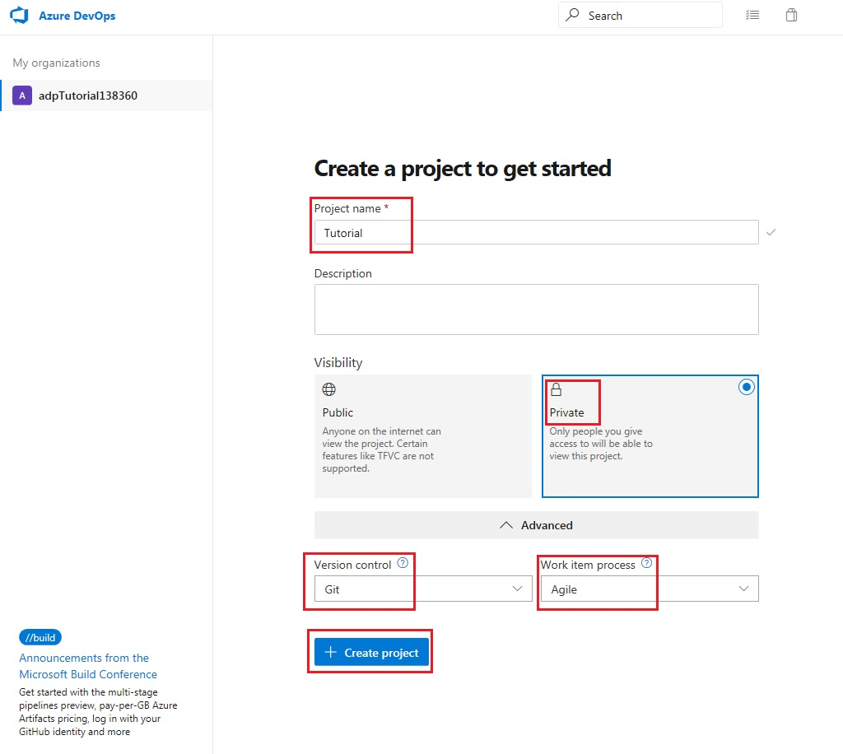

Click on the code icon of the newly created project

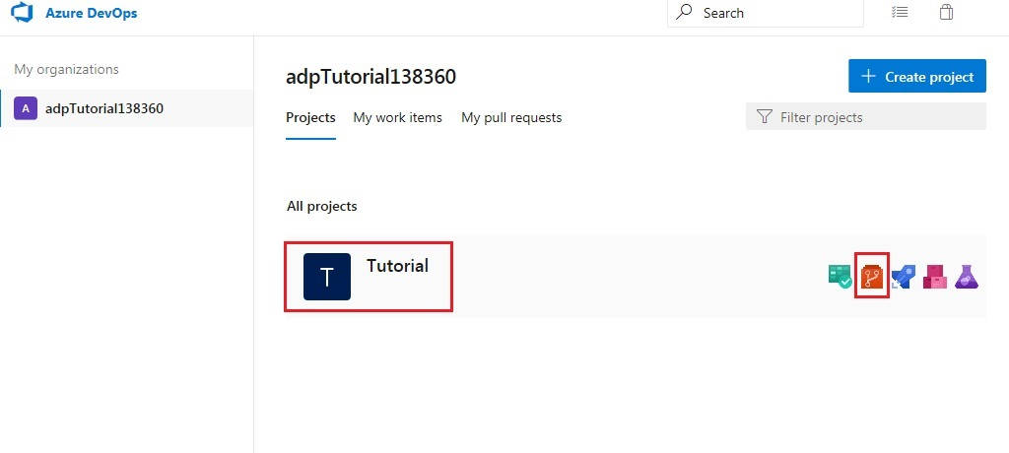

This takes you to the newly created project page with the following greeting message: “Tutorial is empty. Add some code!”. Before adding some code, the repository will need to be cloned in Visual Studio.

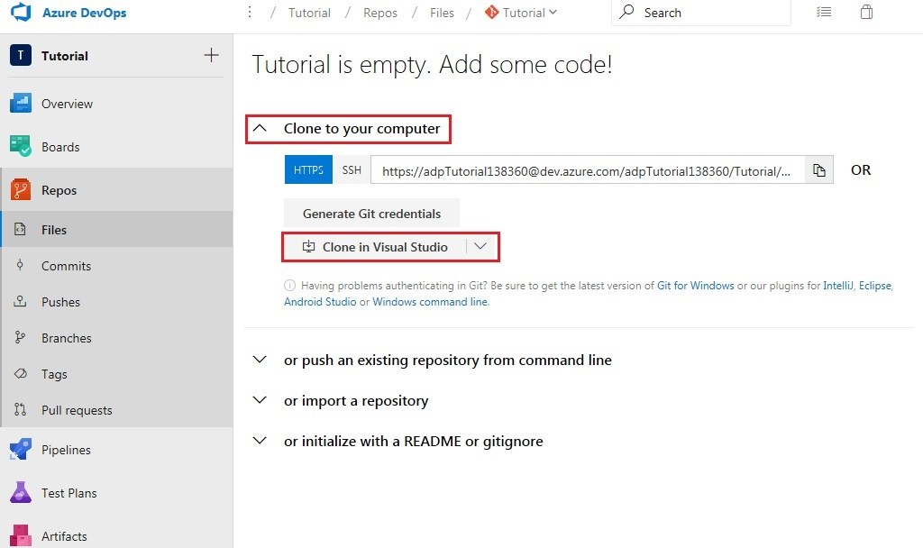

You will be redirected to a new tab with a popup message. Click ‘Allow’ when prompted by your web browser. This will cause Visual Studio to be launched.

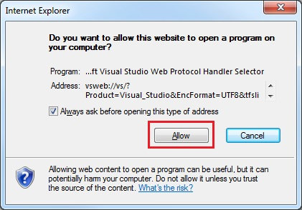

Select an appropriate location and clone the repository to your computer.

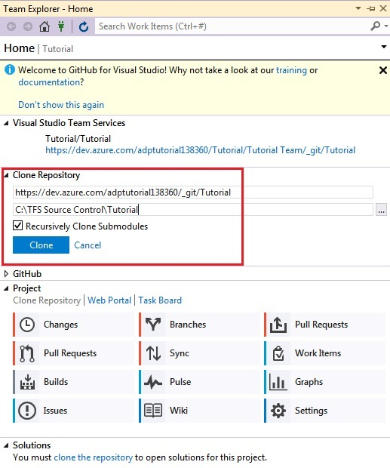

Creating a Xamarin.forms app in vs2017

While in Visual Studio, create a new project as follows

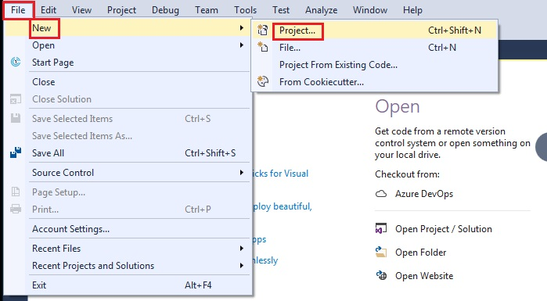

Make sure the location selected matches the folder where your repository was cloned

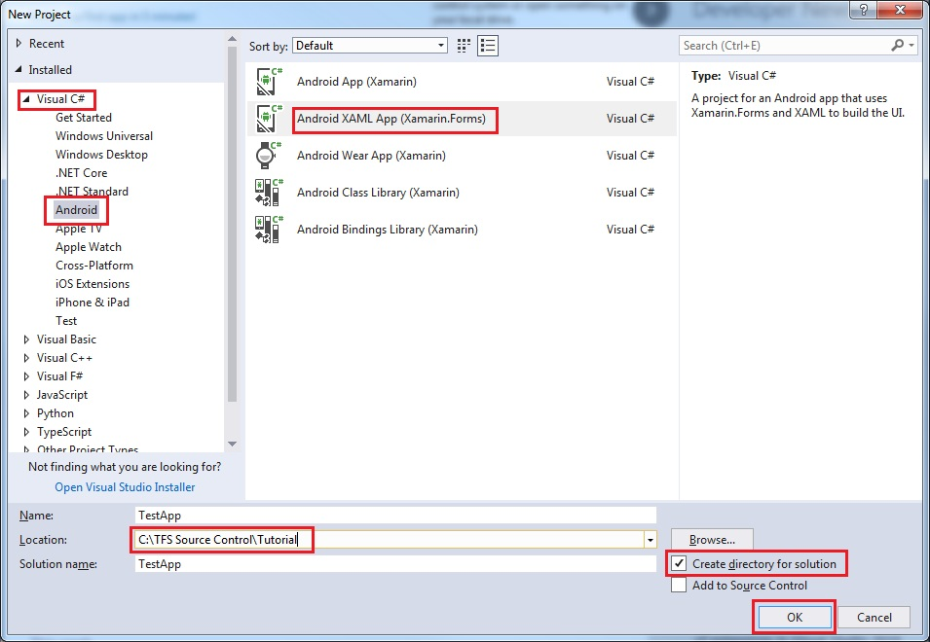

Open the Solution Explorer window in Visual Studio to build the solution. Set build platform, configuration and start-up project as shown below.

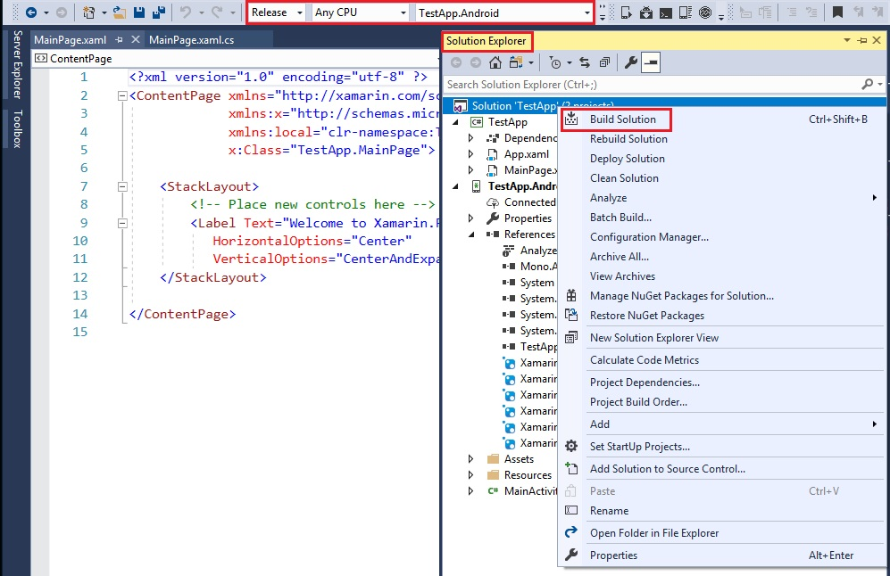

After a few minutes, the Output window in Visual Studio should indicate that the build succeeded.

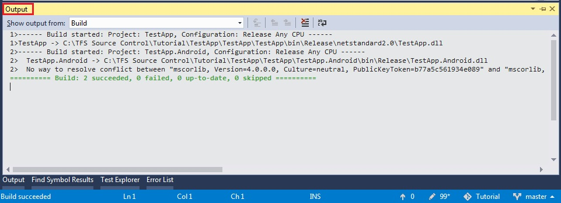

Now, open the Team Explorer window in Visual Studio. Click on the ‘Changes’ button under the ‘Home’ tab.

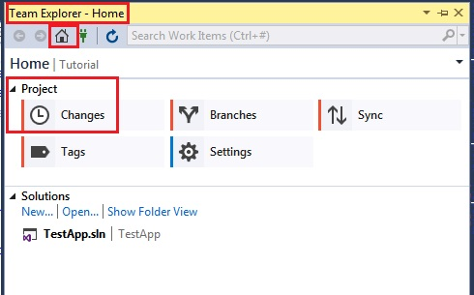

Do not be shocked at the number of changes. As Most of these can be ignored.

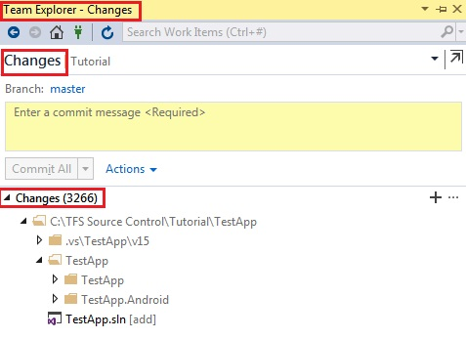

Ignore the following items:

* .vs\TestApp\v15
* TestApp\TestApp\bin\Release\netstandard2.0
* TestApp\TestApp\obj
* TestApp\TestApp.Android\bin\Release
* TestApp\TestApp.Android\obj

This should lead to a considerable decrease in the number of changes as well as an update of the ‘.gitignore’ file which will appear under ‘Staged Changes’.

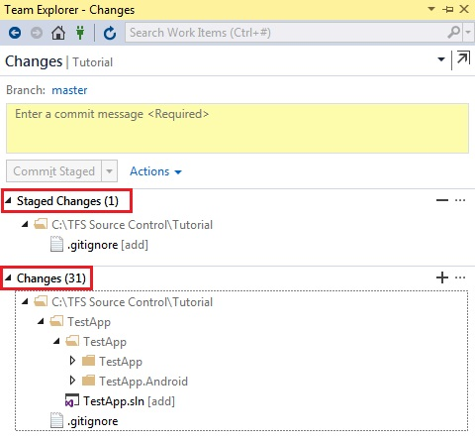

Stage the remaining changes

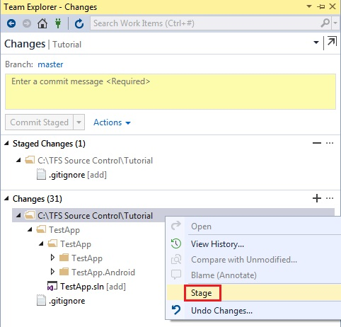

Enter an appropriate comment and commit the changes

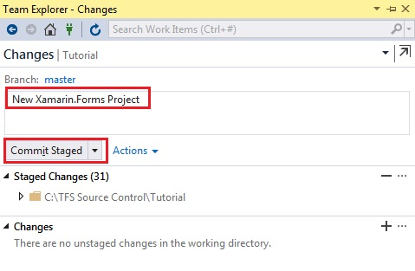

Click on the ‘Sync’ button under the ‘Home’ tab of the Team Explorer window in Visual Studio and ‘Push’ your commit to the server.

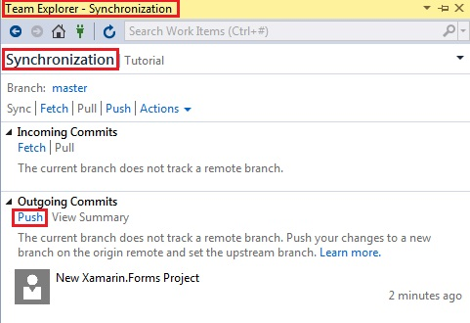

Return to your browser and refresh the tab or access your repository using the following link: [https://dev.azure.com/{username}/_git/{projectname}](https://dev.azure.com/%7busername%7d/_git/%7bprojectname%7d); where {username} is your Azure account name and {projectname} is ‘Tutorial’ or whatever name you chose for the project.

Instead of the previous greeting message, you should now be presented with your TestApp project.

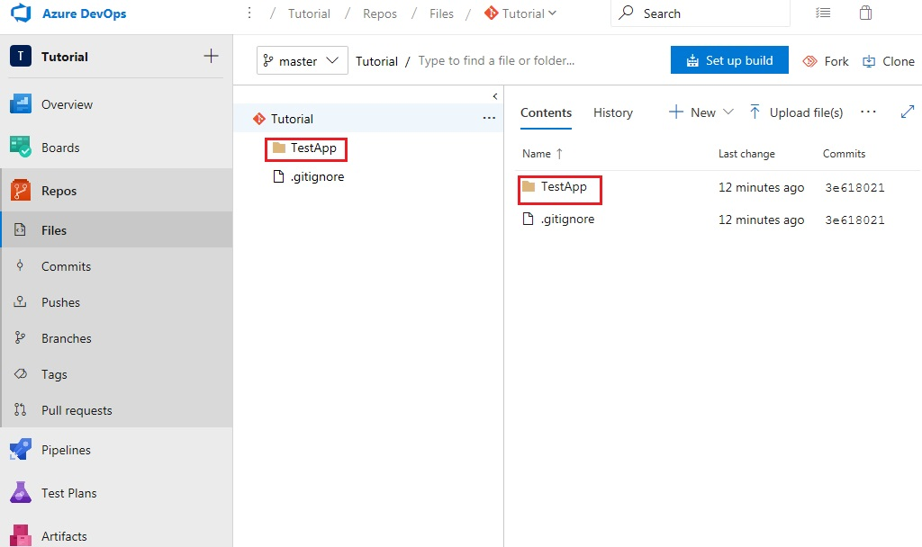

Now that the project has been successfully added to your Azure repository, open a new tab and navigate to your app Center dashboard using the following link: https://appcenter.ms/apps

Once you’ve signed in, select the ‘Add new’ button to create a new app as shown below. Make sure that the app name matches the name of the Xamarin.Forms project created in Visual Studio.

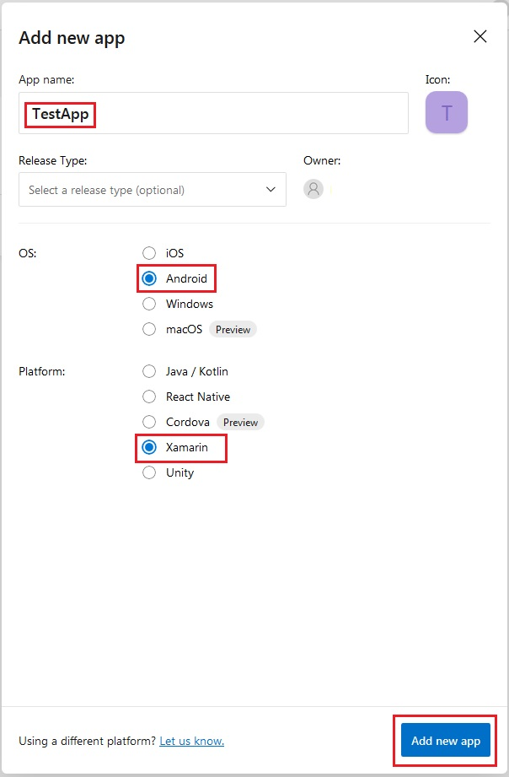

Now return to your Azure Repository to setup the build pipeline

Setting up the build pipeline

Basic pipeline

Additional tasks

Setting up the release pipeline

Basic pipeline

Deployment to app center

Deployment gates

Approvals